EMPLOYMENT OPPORTUNITY
EMPLOYMENT OPPORTUNITY

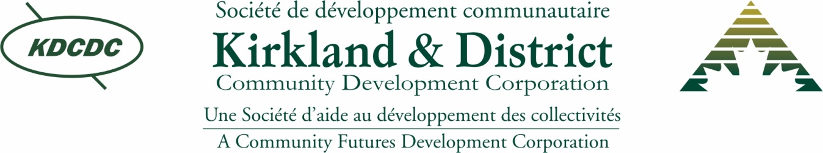

Partners for Opportunity / Parternaire pour des opportunités

Business/Community Development Intern
1 Year Contract

KDCDC will partner with its communities, businesses, groups and individuals to create opportunities to diversify, sustain, and stabilize the economy, leading to wealth and prosperity for KDCDC’s region.

La Société de Développement Communautaire de Kirkland et du District (KDCDC) établira des partenariats avec les collectivités, les entreprises, les individus, groups et organisms communautaires afin de diversifier, soutenir et stabilizer l'économie locale, ce qui pourra mener vers une croissance et prospérité économique pour notre region.

Kirkland & District Community Development Corporation is seeking a dynamic, individual to market and coordinate community development in our area.

JOB LOCATION: Kirkland Lake, ON

JOB DESCRIPTION – The Intern will provide project support and marketing support
- Assist smaller rural communities, not for profit organizations and First Nations, with website development, with an emphasis on social media marketing, to better promote economic opportunities and awareness.
- Contribute to economic and demographic information for communities.
- Gather information to area employers to identify businesses requiring support with succession planning.
- Coordinate services including workshops/ seminars that are offered by partner organizations, to assist businesses.
- Identify opportunities for new inclusive events in the region
- Develop a user-friendly education tool on digital marketing which will be prepared and tested for the purposes of education KDCDC client communities and businesses.

SKILLS:
- Communication and interpersonal skills, consultative, presentation skills
- Planning and organizational skills, ability to prioritize in a changing environment and among competing demands;
- Official Language proficiency is an asset
- Working knowledge of computers eg: Microsoft Office, social media & Internet Explorer
- Clear Criminal Reference Check and Vulnerable Sector Screening
- Must have valid driver’s license
INTERNSHIP ELIGIBILITY CRITERIA – Successful candidates must:
- Be unemployed / underemployed
- Be under the age of 30
- Have graduated within the last three years with a degree/diploma from an accredited college/university
- Be legally entitled to work in Canada.
- Has not participated as a youth intern in any of FedNor’s Programs or in any other federal or provincial internship program with pay for a period of six months or more.
SALARY: This full time 1-year contract position is partially funded by FedNor and the Government of Canada.
Submit application by email to: ed@kdcdc.com by September 9th,2020
Jessica Lafreniere
Execustive Director
Kirkland & District Community Development Corporation
P.O. Box 128
23 Government Road East
Kirkland Lake, ON P2N 3M6
Tel: (705) 567-3331
Toll Free: 800 297-7347
Fax: (705) 567-6565
Website: www.kdcdc.com

